Jingle Store

Catching customers in 30secs

# about us:

Jingle Store writes and produces musical jingles for radio, television, and web advertising. We take care of everything, from creating the slogan to the background music with or without vocals.

Currently our company consists of four members: an accountant, a sound engineer, a song writer, and a music producer. The company has been in business since 2009, and has noticed how consumers now do most of their shopping online, including music. Our goal is to keep up with the times by providing customers with a variety of jingles to select from on JINGLE STORE. Whether it be a soft, slow, and sexy song to promote your next product or an upbeat and catchy tune to let your customers know about your next big sale, JINGLE STORE is the place to go.

As of now we are selling our jingles directly to companies in the city or via third party radio stations but we feel it’s time to broaden our market and take on the world by diving into the internet. By making an e-commerce store, we will be able to target not only companies who reside in Winnipeg but across the country.

# Homepage Wireframe

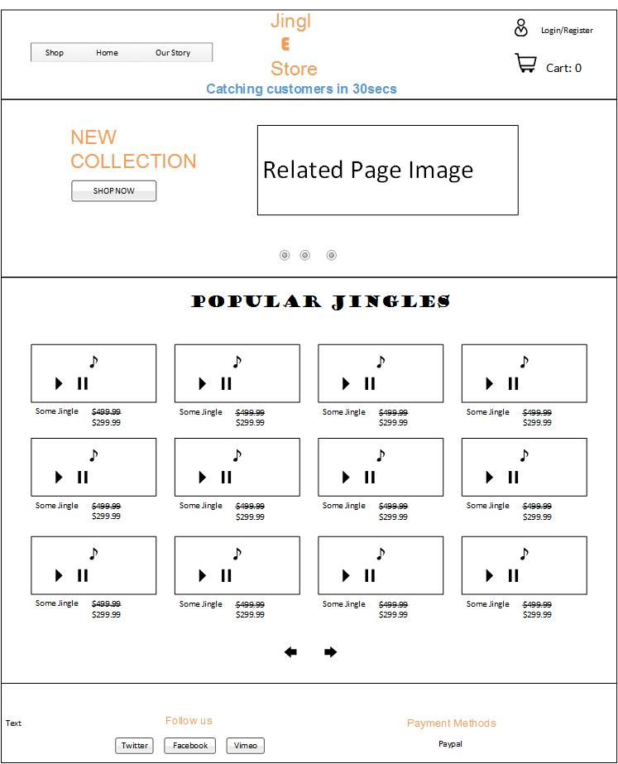

# Database Structure

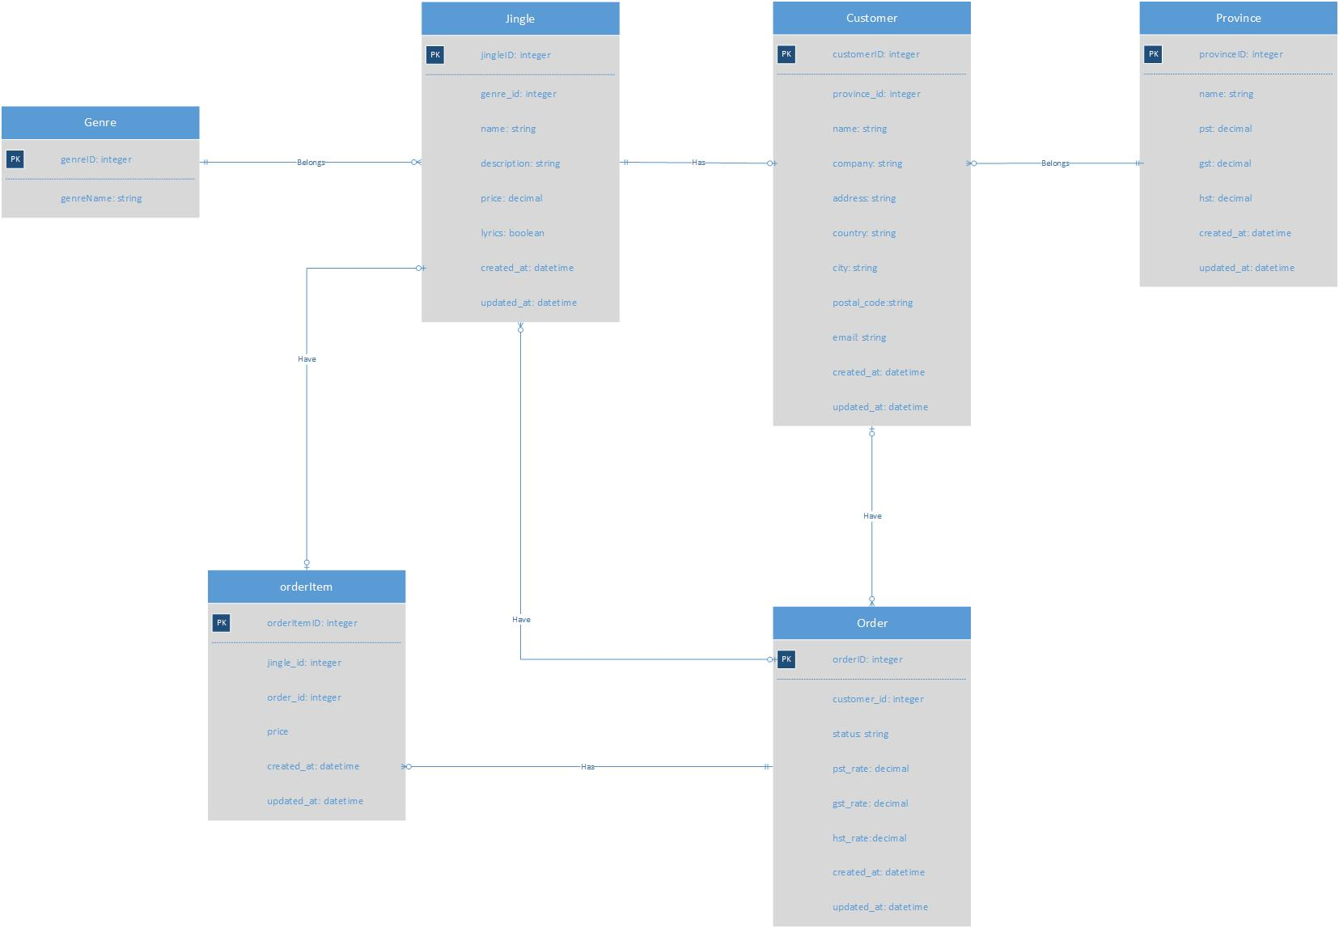

## Tables:

* Genre – This will hold the genre of the jingle
  + Alternative
  + Anime
  + Blues
  + Children’s
  + Classical
  + Rock
  + Singer/Songwriter
  + World
  + Pop
* Jingle – This is the actual product being sold, this table will hold all jingles the store creates
* Customer – This table holds the customers that will be purchasing or have purchase jingle/s
* Province – This table will hold the information of what province the customer is from, also the taxes involve in a particular province
* Order – the order table holds the order/s being produce by a particular customer
* OrderItem – this table holds the jingle per line being process in an order.

# Project Goals and Milestones

* The total number of marks you hope to have accumulated by the end of the project
  + My plan and goal is to accumulate the mark of 80 by the end of the project
* A milestone date for the completion of 25% of the total marks you estimated above.
  + My estimated 25% date is around Monday November 17, 2014
* A milestone date for the completion of 50% of the total marks you estimated above.
  + My estimated 50% December 1, 2014
* I plan to demonstrate my achievements and goals by adding up the marks and showing my client on a weekly basis the working process, making sure things are good with him.

# Strengths and Weaknesses

|  |  |
| --- | --- |
| STRENGTHS | WEAKNESSES |
| I am consider to be an artistic type of person | I need to better manage my already busy life more |
| Have designed two websites for real business | Need to gain more knowledge and passion for RUBY and rails programming. |
| Have coded and design a website of my own | I need to pace myself when tackling a big project |
| Have knowledge on the concepts of CRUD | I’m a natural night owl, I function better at nights, thus making very tire when coming to school to learn more because I been up doing assignments. |
| Learn to code many applications in different languages such as HTML5, XML, JAVA, .NET, |  |
| I am consider to be persistent but mindful of my client’s needs. |  |